TENDER TALENTS MAGNET SCHOOL
END OF TERM I ASSESSMENT 2024
SENIOR ONE BIOLOGY
Time :2Hrs
NAME:……………………………………..STREAM:……...SINATURE:………………
Instructions.
Answer all questions in the spaces provided.
Answer all questions in this section in the spaces provided.
1. A strange flying pest has attacked crop farms in KASANGATI. The pest destroys crops by injecting them with a fluid, which dries them up. Residents have suggested to form a team of specialists to fight the pest and its effects.
a) Identify the braches of Biology from which a team of specialists must be obtained. (03 marks)

…………………………………………………………………………………………………………………………………………………………………………………………………………………………………………………………………………………………………………………………………………………………………………………………………………………………………………………………………………………………………………………………………………………………………………………………………………………………………………………………………………………………………………………………………………………………………………………………………..
2. What would happen to a muscle cell if the following structures stopped working? (04 marks)
a) Nucleus
…………………………………………………………………………………………………………………………………………………………………
- b) Mitochondrion
…………………………………………………………………………………………………………………………………………………………………
- c) Cell membrane
……………………………………………………………………………………………………………………………………………………………
- d) Cytoplasm
…………………………………………………………………………………………………………………………………………………………………
3. The organisms shown in the figure 1 belong to the same biological grouping.

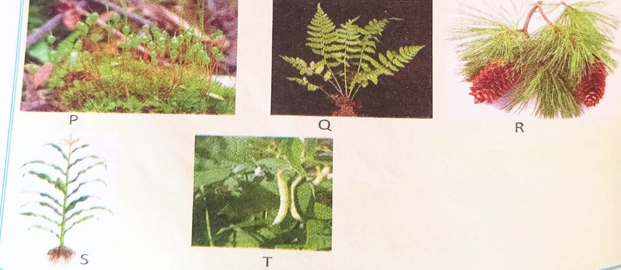
a) To which grouping do the organisms belong? (01 mark)
……………………………………………………………………………………………………………… ……………………………………………..
- b) Why do they belong to that group? (03 marks)
…………………………………………………………………………………………………………………………………………………………………
………………………………………………………………………………………………………………………………………………………………..
- c) Give two differences between the organism S and Q in figure 1 above. (02 marks)

……………………………………………………………………………………………………………………………………………………………………………………………………………………………………………………………………………………………………………………………………………………………………………………………………………………………………………………………………………………………………..
4. Mampi, a senior one student was tested and found with HIV/AIDS. His best friend Kagoda now fears to play or sit next to her because he thinks that he will also contract HIV/AIDS.
a) Do you think Kagoda is right? Why? (02 marks)
…………………………………………………………………………………………………………………………………………………………………………………………………………………………………………………………………………………………………………………………………..
- b) As a friend to both, what advice can you give Kagoda? (03 marks)
………………………………………………………………………………………………………………………………………………………………
……………………………………………………………………………………………………………………………………………………………………………………………………………………………… ……………………………………………………………………………………………………

5. Figure 2 shows a flow chart used to identify insects.
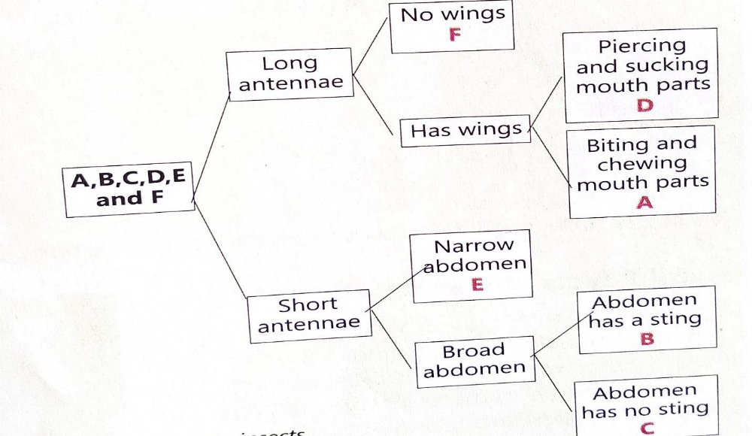

Use the flow chart to identify which of the insects; cockroach, bee, housefly, mosquito, butterfly and termite are represented by letters A to F. (06 marks) …………………………………………………………………………………………………………………………………………………………………
………………………………………………………………………………………………………………………………………………………
…………………………………………………………………………………………………………………………………………………………
6. Closely look at the following scientific names; zea mays, loxodonta Africana, Lantana Camara, Mangifera-indica. State how best these names can be written following the binomial nomenclature system. (04 marks)

…………………………………………………………………………………………………………………………………………………………………
…………………………………………………………………………………………………………………………………………………………………
7. On her way to school, Cathy came across an exciting organism resting on a tree branch. She could not identify it but said it had fur all over its body, it was eating a banana with different shapes of teeth in its jaw.
a) Help Cathy identify the organism using its kingdom, phylum and class. (03 marks)

Kingdom ……………………………………………………………………………………………………………….

- )

………………………………………………………………………………………………………………………………………………………………………………………………………………………………

- marks)
……………………………………………………………………………………………………………………………………………………………………………………………………………………………………………………………………………………………………………………………
………………………………………………………………………………………………………………
- c) Apart from class insect, state any other two classes in phylum Arthropoda. (02 marks)

………………………………………………………………………………………………………………………………………………
…………………………………………………………………………………………………………………………………………………
END

